**GAMES LEVEL DESIGN – MINI PROJECT LEVEL DESIGN REPORT**

|  |  |
| --- | --- |
| **Game Concept** | First-person shooter/beat-em-up, Metroidvania-ish |
| **Theme** | Sci-fi, Abstract low-poly style |
| **Environment** | Guided Open world |
| **Goal/ Objective** | Get to the exit / Escape the facility |
| **Challenge** | Player has to manage sanity and health by switching body parts with the enemies they have defeated and gain enough power to reach the exit |
| **Reward/ Motivation** | Sanity is an ever lowering resource to punish players who take a backseat while rewarding a more aggressive and engaging playstyle, as they can take upgrades instead of spending them on regaining sanity. |
| **Way of handling failure** | The player loses when sanity or health reaches 0, when that happens they get sent to the game over page where they can restart. |

**Concept (Images for reference, theme and design)**

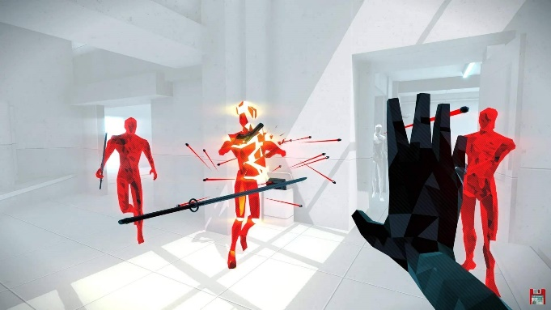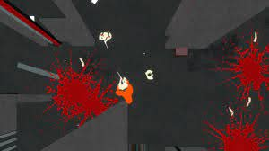  
from Superhot, will emulate a similar aesthetic. From Ape Out, similar aesthetic and gameplay style

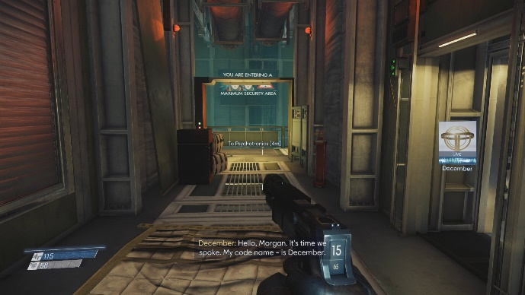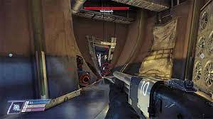

Prey inspired level design, with different ways of getting through a blockade

**Map/Level Design (Drawn or Screen shot captured from your game)**

* Indicate challenges, rewards, interactive features on map.
* Indicate spawn points, ammos, health, etc.

**Level Objective/ Solutions**

* Provide a brief write up with images (if necessary) on the strategy or procedures to complete the level/levels.

**Questions**

1. **How do you ensure that the difficulty of the game is appropriate?**
2. **What are the obstacles introduced to slow down the players, and what are the skills required to overcome them? Refer to chapter 05 & 06 of the notes on the details for challenges and obstacles.**
3. **What are the rewards or motivation provided to encourage players in overcoming the challenges?**

**References**

* **Background Music:** [**https://www.fesliyanstudios.com/royalty-free-music/download/retro-platforming/454**](https://www.fesliyanstudios.com/royalty-free-music/download/retro-platforming/454)
* **Outline Shader:** <https://github.com/Shrimpey/UltimateOutline> (edited version by me)
* **Everything else is done by me**